Database Design Project

**Oracle Baseball League Store Database**

**Project Scenario:**

You are a small consulting company specializing in database development. You have just been awarded the contract to develop a data model for a database application system for a small retail store called Oracle Baseball League (OBL).

The Oracle Baseball League store serves the entire surrounding community selling baseball kit. The OBL has two types of customer, there are individuals who purchase items like balls, cleats, gloves, shirts, screen printed t-shirts, and shorts. Additionally customers can represent a team when they purchase uniforms and equipment on behalf of the team.

Teams and individual customers are free to purchase any item from the inventory list, but teams get a discount on the list price depending on the number of players. When a customer places an order we record the order items for that order in our database.

OBL has a team of three sales representatives that officially only call on teams but have been known to handle individual customer complaints.



Copyright © 2020, Oracle and/or its affiliates. All rights reserved. Oracle and Java are registered trademarks of Oracle and/or its affiliates. Other names may be trademarks of their respective owners.

# Section 6 Lesson 7 Exercise 2: Restricting Data Using WHERE

**Limit rows using WHERE (S6L7 Objective 1)**

In this exercise you will refine the data that is returned in your query by adding a WHERE clause to your SELECT statement.

## Part 1: Using the NULL Conditions

1. Write a query that will display information for teams that don’t receive a discount in the following format:

The Rovers team has 25 players and does not receive a discount.

Use **Team Information** as the column alias.

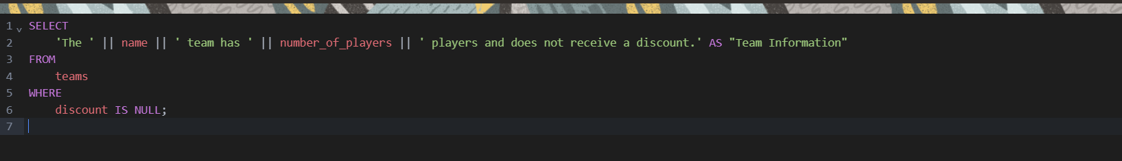

1. Write a query that will display information for only teams that receive a discount in the following format:

The Rockets team has 25 players and receives a discount of 10 percent.

Use **Team Information** as the column alias.

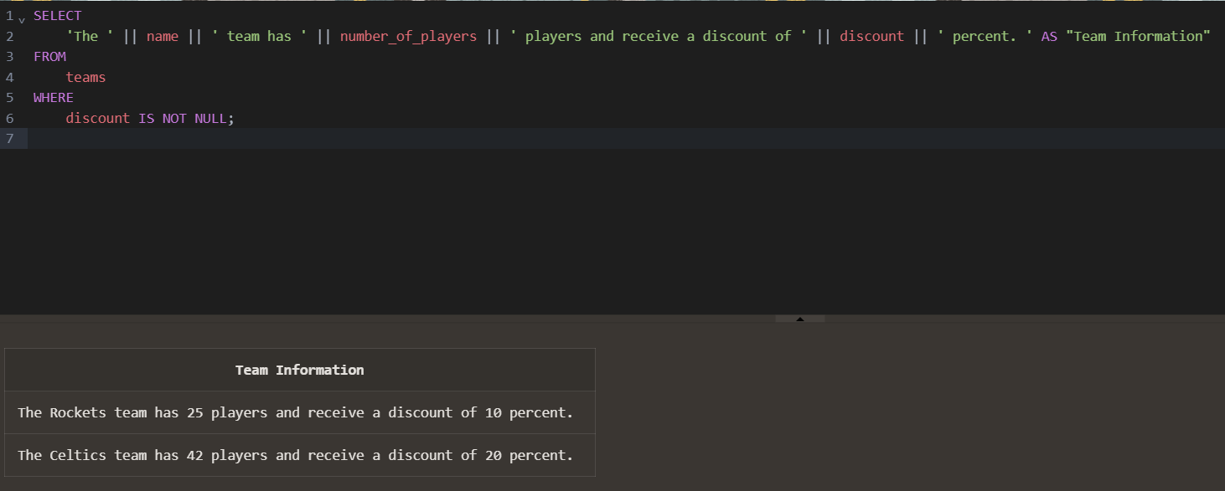

## Part 2: Logical Operators: AND

1. Write a query that will display the customer number, address line 1 and postal code for customers that live in the starford area of Liverpool. Use Customer Number, Street Address and Postal Code as the column aliases.

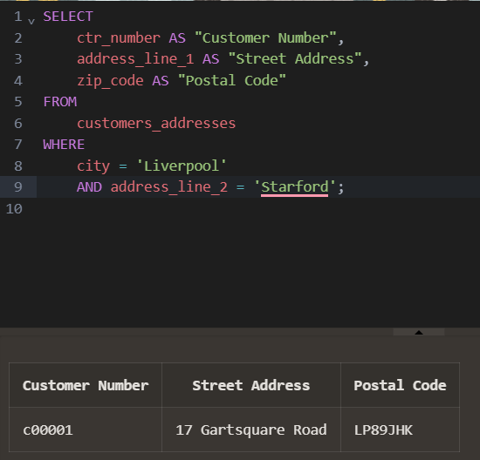

## Part 3: Logical Operators: OR

1. Write a query that will display the customer number, address line 1 and postal code for customers that live in either starford or Liverpool in general. Use Customer Number, Street Address and Postal Code as the column aliases.

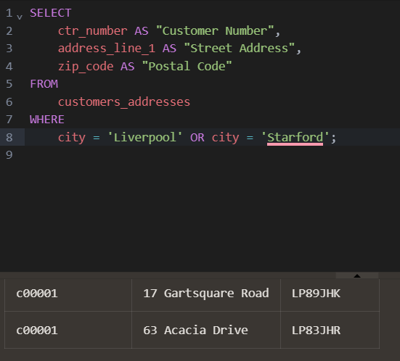

## Part 4: Logical Operators: NOT Equal To

1. Write a query that will display the customer number, address line 1 and postal code for customers that do not live in Liverpool. Use Customer Number, Street Address and Postal Code as the column aliases.

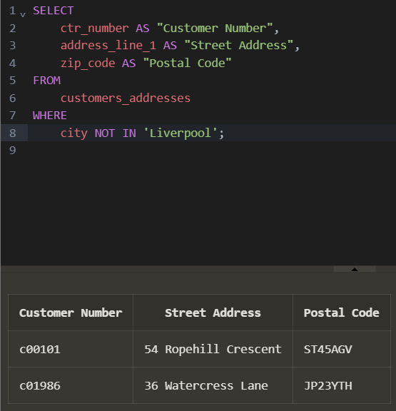

Copyright © 2020, Oracle and/or its affiliates. All rights reserved. Oracle and Java are registered trademarks of Oracle and/or its affiliates. Other names may be trademarks of their respective owners.

2